# A

## PROJECT REPORT

ON

### GAMING GEARS: WEB BASED APPLICATION FOR SHOPPING GAMING COMPONENTS AND WITH EXPERT GUIDENS.

Submitted in partial fulfillment for the award of

Post Graduate Diploma in Advance Computing

# (PG-DAC) from

### INSTITUTE OF EMERGING TECHNOLOGIES

Authorized Training Centre



### Under the Guidance of Mrs. Prachi Godbole BY

**Name of student/s and PRN**

|  |  |
| --- | --- |
| 1. Gajendrakumar Bhokre | 230345920031 |
| 2. Manish Y Gaikwad | 230345920030 |
| 3. Ganesh S Balki | 230945920032 |
| 4. Swapnil A Kakade | 230345920104 |



# CERTIFICATE

This is to certify that the project report entitled **GAMING GEARS : WEB BASED APPLICATION FOR SHOPPING GAMING COMPONENTS WITH AND EXPERT GUIDENS** is a bonfire work carried out **by1. Gajendrakumar Bhokre , 2. Manish Y Gaikwad, 3. Ganesh S Balki, 4. Swapnil A Kakade** submitted in partial fulfillment of the requirement for the C-DAC ACTS, DAC course in the Institute of Emerging Technology in the batch of March 2023.

**Course Coordinator** **External Examiner**

**ACKNOWLEDGEMENT**

This project **GAMING GEARS: WEB BASED APPLICATION FOR SHOPPING GAMING COMPONENTS AND WITH EXPERT GUIDENS** was a great learning experience for us and we are submitting this work to Advanced Computing Training School (CDAC).

We are very glad to mention **Mrs. Prachi Godbole** for her valuable guidance to work on this project. Her guidance and support helped us to overcome various obstacles and intricacies during the course of project work.

Our most heart full thanks goes to ***Mr. Sangram Patil* (Director, IET)** who gave all the required support and kind coordination to provide all the necessities like required hardware, internet facility and extra lab hours to complete the project and throughout the course up to the last day here in C-DAC ACTS, Pune.

### Name of Student

|  |  |  |  |
| --- | --- | --- | --- |
| **Sr.No.** | **Name** | **PRN** | **Sign** |
| 1. | Gajendrakumar Bhokre | 230345920031 |  |
| 2. | Manish Yashwant Gaikwad | 230345920030 |  |
| 3. | Ganesh Sainath Balki | 230345920032 |  |
| 4. | Swapnil Anil Kakade | 230345920104 |  |

**INDEX**

|  |  |  |
| --- | --- | --- |
| **Sr. No.** | **Title** | **Page No.** |
| 1 | Introduction | 5-6 |
| 1.1 | Purpose | 5 |
| 1.2 | Need of System | 5 |
| 1.3 | Overview | 6 |
| 2 | Problem Definition and Scope | 7-9 |
| 3 | Software Requirement Specification | 10 |
| 3.1 | Proposed System and Scope | 10 |
| 4 | System Modules | 11 |
| 5 | Performance-Requirements | 12-13 |
| 5.1 | H/W Requirements & S/W Requirements | 13 |
| 6 | UML Diagram | 14-23 |
| 6.1 | DFD | 14-16 |
| 6.2 | ERD | 17-18 |
| 6.3 | Use case diagram | 19 |
| 6.4 | Class Diagram | 20 |
| 6.5 | Sequence diagram | 21 |
| 6.6 | Activity Diagram | 22 |
| 6.7 | Deployment diagram | 23 |
| 6.8 | System Architecture |  |
| 7 | Test Cases | 24-27 |
| 8 | Screenshots | 28-32 |
| 9 | References | 33 |

# INTRODUCTION

The Gaming Enthusiasts E-commerce Platform is an online destination tailored for gaming enthusiasts, offering an extensive array of gaming gear. Notably, the platform stands out by enabling expert gamers to create and share precise gaming setup lists, providing valuable insights. This document details the functional and non-functional prerequisites crucial for developing this dynamic platform.

## Purpose

The main objective of this Gaming Gears Software Requirement Specification (SRS) is to provide a foundation for the project. It offers a comprehensive view of how the system is supposed to work and what end users can expect. The client’s expectations and requirements are analyzed to produce specific, unambiguous functional and non-functional requirements. These requirements can then be used by the development team to build a system that aligns with the end users' needs.

This SRS for Gaming Gear can also serve as a future reference for understanding how the project was initiated. It provides a blueprint for upcoming new developers and maintenance teams, assisting them in maintaining and modifying this project according to required changes.

## Need Of Online Shopping Website

1.Performance: Gamers require high-performance PCs that can handle demanding games smoothly. They seek PCs with powerful processors, high-end graphics cards, sufficient RAM, and fast storage options to ensure optimal gaming experiences.

2.Customizability: Many gamers prefer the option to customize their gaming PCs based on their specific preferences and needs. Online stores that offer a variety of components and customization options are attractive to this audience.

3.Technical Specifications: Shoppers need detailed technical specifications for each component, including the processor, graphics card, RAM, storage, and more. Accurate and comprehensive information helps them make informed purchasing decisions.

4.Compatibility: Ensuring that all components are compatible with each other is crucial. Online stores need to provide compatibility information to prevent customers from purchasing incompatible parts.

## Overview

This section offers a comprehensive overview of gaming components in the context of a gaming PC. It outlines the functions of key elements such as the CPU, GPU, RAM, storage, and cooling solutions. It delves into their collaborative role in providing a smooth gaming experience, highlighting the significance of component synergy. Additionally, it emphasizes the critical task of balancing these components to achieve peak performance not only in gaming but also across various tasks.

# PROBLEM DEFINITION AND SCOPE

## Problem statement and Scope of the Project

**Problem Statement:**

The challenge at hand revolves around the complexities faced by gamers when purchasing gaming PCs from online platforms. This process entails navigating various technical specifications, compatibility concerns, pricing structures, and the delicate balance between performance and budget limitations. Additionally, gamers exhibit diverse preferences, ranging from cost-conscious students to performance-driven professionals. The central issue addressed by this project is the need to enhance and streamline the online gaming PC shopping experience, alleviating these obstacles and catering to the wide array of gamer requirements.

**Scope of the Project:**

The scope of this project encompasses the development of an online platform that offers a comprehensive and user-friendly solution for individuals seeking to purchase gaming PCs. The platform will cater to the needs of both students and working professionals by providing tailored shopping experiences that align with their requirements. The key features and components of the project include:

**1.User Profiles and Preferences:**

Users can create profiles specifying their gaming preferences, budget range, and technical requirements. The platform will offer personalized recommendations based on user profiles.

**2.Customization Options:**

Gamers can customize pre-configured gaming PC packages or assemble their PCs from scratch by choosing components that align with their preferences.

**3.Compatibility Assurance:**

The platform will provide real-time compatibility checks to ensure selected components are suitable and functional together.

**4.Budget-Friendly Solutions:**

Providing affordable options for gamers seeking cost-effective solutions.

**5.Smooth Checkout and Payment:**

An intuitive shopping cart system with secure and convenient payment options.

Order tracking for users.

**6.Expert Support:**

Responsive support for technical inquiries, compatibility concerns, and general assistance.

## Goals and Objective

**Goals:**

* **Enhanced User Experience:** The primary goal of the project is to create an online gaming PC shopping platform that offers an exceptional user experience. This includes intuitive navigation, comprehensive product information, and a seamless customization process.
* **Informed Decision-Making:** The platform aims to empower users with the knowledge needed to make informed decisions. By providing detailed technical specifications, expert suggestions, users can confidently choose components that match their gaming preferences and requirements.
* **Personalization:** The project aims to deliver a uniquely personalized shopping journey for gamers. Whether they are casual players seeking affordable options or competitive gamers requiring high-performance setups, the platform will curate recommendations based on individual gaming preferences and requirements.
* **Simplified Customization:** The platform's objective is to simplify the process of customizing gaming PCs. Users should be able to easily select components, ensuring compatibility and optimal performance without requiring in-depth technical knowledge.
* **Expert Guidance:** By incorporating expert-curated suggestions for gaming PC configurations, the project aims to assist users in creating setups that align with their gaming needs. This guidance will cater to both novices and enthusiasts.

**Objectives:**

* **Product Catalog:** Assemble an extensive selection of gaming PC components, including CPUs, GPUs, RAM, and storage, accompanied by comprehensive specifications. This detailed catalog will empower users to make informed decisions.
* **Expert Suggestions:** Collaborate with experienced gaming professionals to curate expert-backed recommendations for different levels of performance. This collaborative input will encompass a broad spectrum of gaming preferences.
* **Compatibility Checks:** Develop a system that conducts real-time compatibility assessments to ensure that the chosen components harmonize effectively, preventing any technical issues.

**• Budget Options:** Provide a range of options to cater to diverse budgets. Offer affordable selections while also providing high-performance solutions for professionals.

## Product Functions

Our Product General functions are:

* + - User Registration
    - search Products
    - Check for Availability of Product
    - Display the Prize
    - Set Product Details
    - Payment
    - Manage Order Details
    - Expert Service

## User Characteristics

There are 4 user Levels in our Gamming Gears :

1. Customer
2. Expert
3. Admin
4. Distributor

#### Customer

#### Users can create new accounts by providing necessary information such as name, email, and password.

#### Expert

* Experts possess the ability to peruse user queries, utilizing their expertise to provide optimal solutions that effectively address user concerns and inquiries.
* Experts retain the authority to remove queries from their queue, allowing them to omit requests they deem inappropriate or beyond their purview of knowledge. This ensures the delivery of accurate and pertinent responses.

#### Admin – Support

* Administrators ensure smooth organization management, distributors enable product distribution in the supply chain, and experts provide valuable insights for decisions and innovation. All three roles are essential for fostering growth and success in different industries.

**Distributor**

* Distributor typically refers to a company or individual that specializes in selling and distributing gaming PCs and related components.

## Major Constraints and Outcomes

1. **Scalability:** The system needs to be able to handle a large number of users and orders
2. **Security:** Implement measures to protect user data, including personal information, payment details, and transaction history.
3. **Reliability:** The system must be available and responsive at all times to ensure that users can make orders and access their information without interruption.
4. **Integration:** Facilitate seamless integration with various payment methods, including cash on delivery and card payments, to provide convenient options for users.
5. **Customizability:** Allow users to customize gaming component specifications based on their preferences and budget constraints.
6. **Cost-Effective Quality Components:** Curate a selection of gaming components that offer a balance between affordability and high quality, enabling users to make cost-effective choices.
7. **Expert Guidance:**

Provide expert recommendations and insights on gaming component trends to assist users in making informed purchasing decisions

# SOFTWARE REQIREMENT SPEIFICATION

* 1. **Proposed system and Scope:**

The proposed system aims to create a user-friendly application providing clear information about Gaming Computers. It serves two main user groups:

**1. Distributors:** They can automate order management, tracking, and payment handling.

**2. Customers:** They can easily find Gaming PCs and components based on their gaming needs without the hassle of physical searching.

The system benefits distributors by streamlining order and payment processes, and customers by simplifying their search for suitable Gaming PCs or components according to their specifications.

# SYSTEM MODULES

1. **Product search:** Users can quickly locate desired products from a diverse range of options available in the system.
2. **Product search by category:** Customers can narrow down their search by exploring products categorized under various sections.
3. **Customer Management:** This module empowers users to create personal profiles, explore and purchase products, and track their order history.
4. **Expert Management:** Users can either seek tailored advice from experts or browse through a list of available experts for guidance.
5. **Distributor Module:** Distributors gain access to features like profile management, product addition, order viewing, and order history tracking.
6. **Admin Module:** Admins have comprehensive access to customer and distributor details, product listings, order records, payment statuses, and user feedback.

# PERFORMANCE REQUIREMENTS

Performance requirements in a Gaming Gears typically include fast loading times, reliable and secure data storage, and the ability to handle a high volume of simultaneous users and orders. Other important factors may include user-friendly navigation and order interface, mobile compatibility, and integration with payment systems. Additionally, a good Gaming Gears should also have robust reporting and analytics capabilities to help the order management track orders, return, and other important performance metrics.

## Hardware and Software REQUIREMENTS

### External Interface Requirements

User Interfaces

The user interface for system shall be compatible to any type of web browser such as Mozilla Firefox, Google Chrome, and Microsoft EDGE, Opera, BING

Software Interfaces

|  |  |  |  |
| --- | --- | --- | --- |
|  | **FRONT END** | **BACKEND** | **DATABASE** |
| 1 | REACT JS | J2EE | MySQL |

**Hardware Interfaces**

|  |  |  |  |
| --- | --- | --- | --- |
| **Server Side** | | | |
| Monitor | Processor | RAM | Disk Space |
| Resolution: 1024x768 | Intel or AMD 2GHZ OR HIGHER | 4GB | 10GB |
| **Client Side** | | | |
| Monitor | Processor | RAM | Disk Space |
| Resolution: 1024x768 | Intel or AMD 1GHZ DUAL CORE MIN | 2 GB | 128 GB |



**UML DAIGRAM**

**6.1. Data Flow Diagram**

* + 1. **Zero Level Data Flow Diagram**

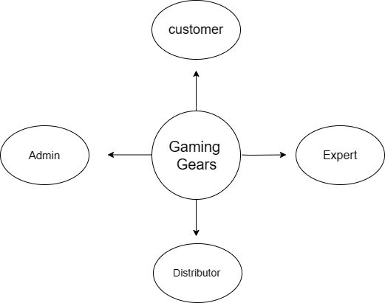

* + 1. **First Level DFD:**

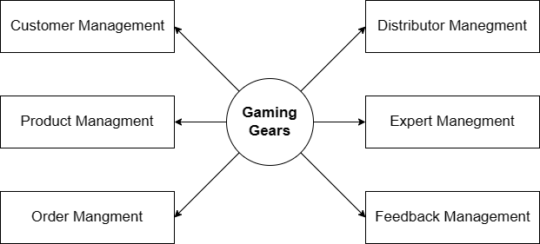

* + 1. **Second Level DFD:**

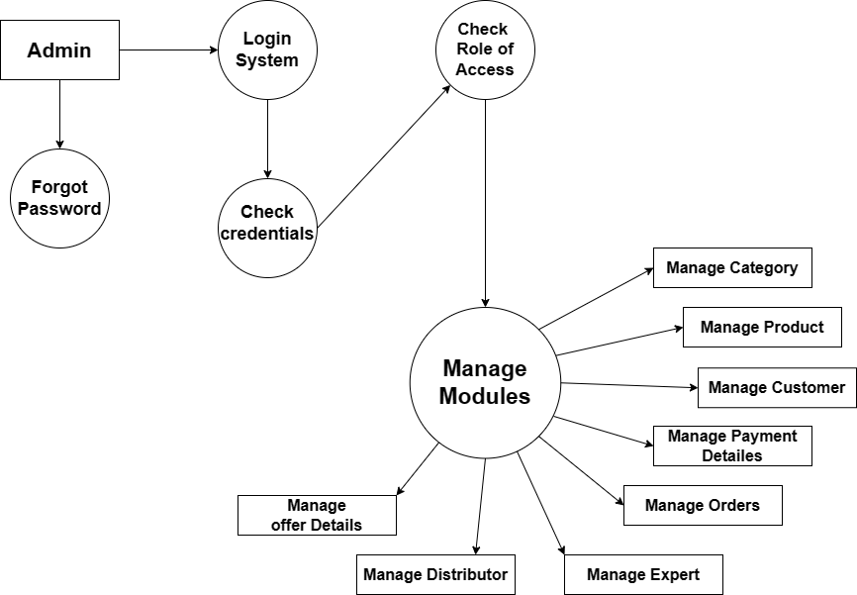



**6.2.1. Entity Relationship Diagram**

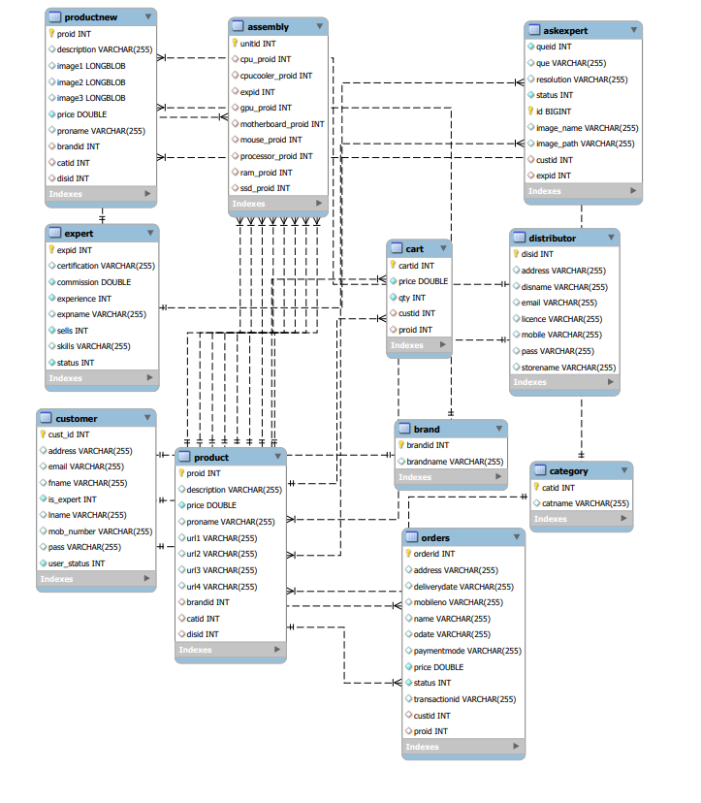

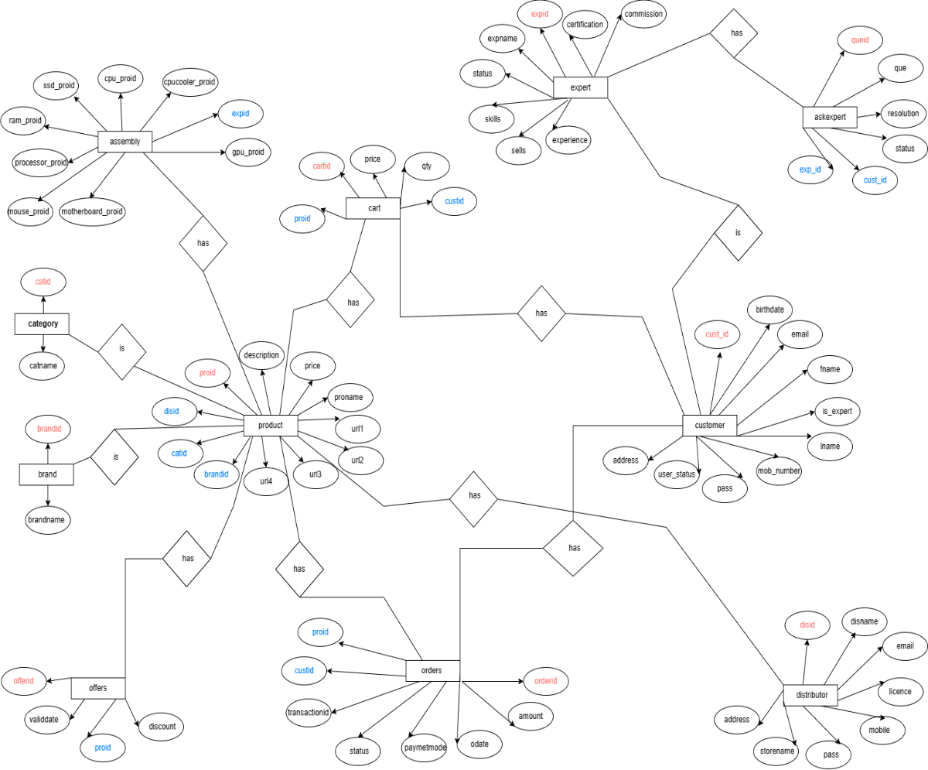

### 6.3. User case Diagram

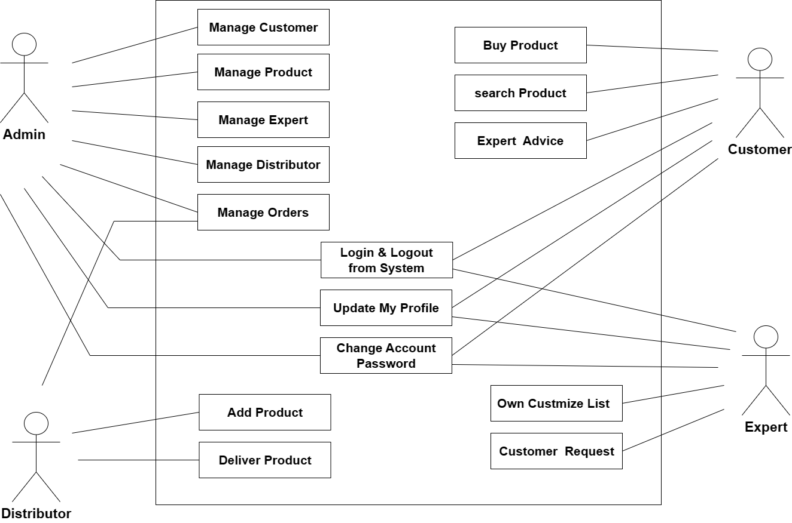

**6.4. Class Diagram**

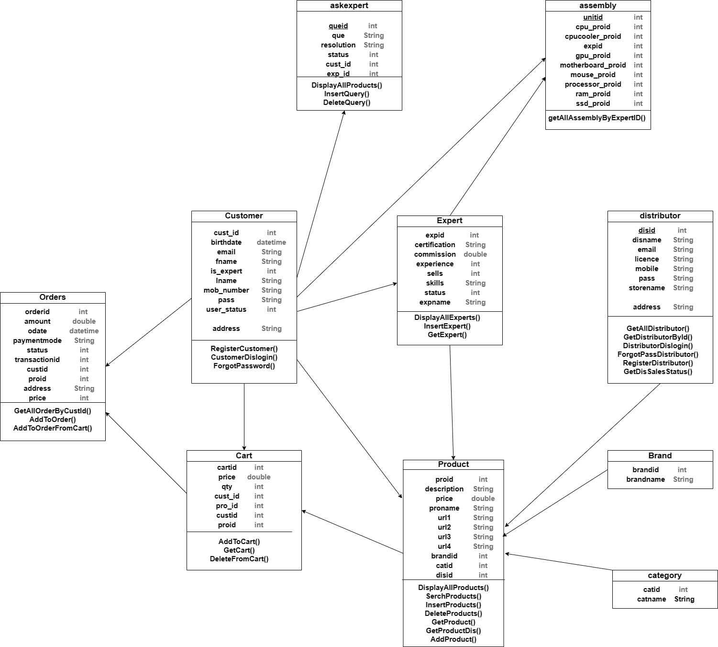

# 6.5 . Sequence Diagram

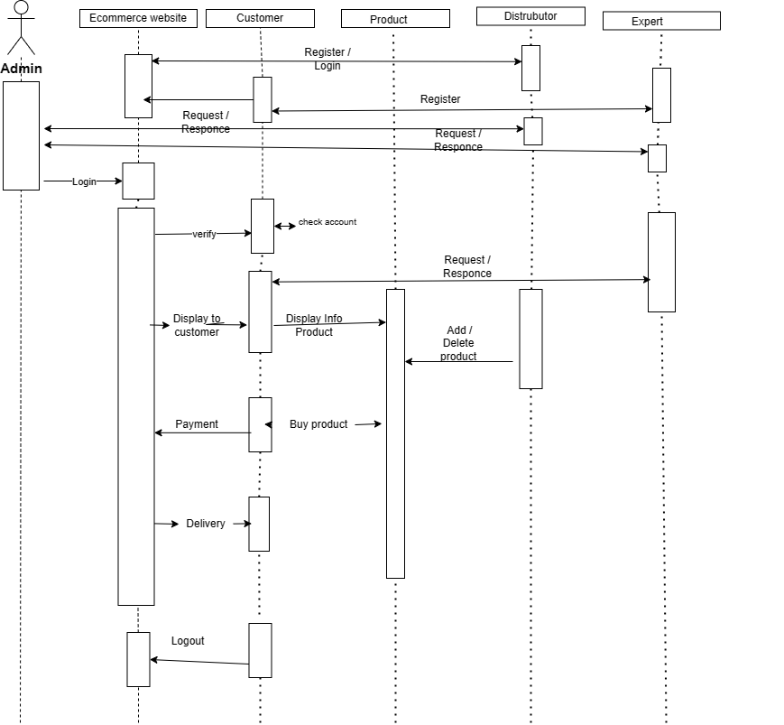

### 6.6.Activity Diagram

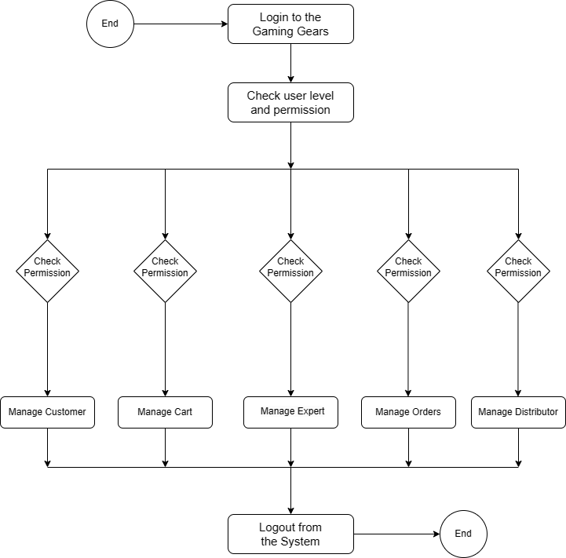

**6.7.Deployment Diagram**

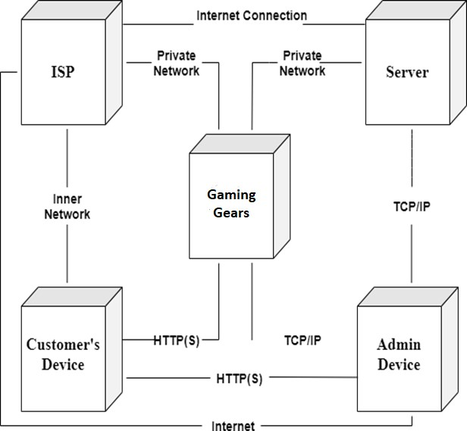

**Test Cases**

#### Login Test Cases

|  |  |  |  |  |  |
| --- | --- | --- | --- | --- | --- |
| **Test Case ID** | **Test Case** | **Test Case I/P** | **Actual Result** | **Expected Result** | **Test case criteria(P/F)** |
| 001 | Admin enter the correct username or password click on submit button | Username or password | Accept | Accept | P |
| 001 | Admin enter the wrong username or password  click on submit button | Username or password | Error come | Accept | P |
| 002 | Customer enter the correct username or password click on submit button | Username or password | Accept | Accept | P |
| 002 | Customer enter the wrong username or password  click on submit button | Username or password | Error come | Accept | P |
| 003 | Expert enter the correct username or password click on submit button | Username or password | Accept | Accept | P |
| 003 | Expert enter the wrong username or password  click on submit button | Username or password | Error come | Accept | P |

**Registration Test Cases**

|  |  |  |  |  |  |
| --- | --- | --- | --- | --- | --- |
| **Test Case ID** | **Test Case** | **Test Case I/P** | **Actual Result** | **Expected Result** | **Test case criteria(P/F)** |
| 001 | Enter the number in username, middle name, last name field | Number | Error Comes | Error Should Comes | P |
| 001 | Enter the character in username, middle name,  last name field | Character | Accept | Accept | p |
| 002 | Enter the invalid email id format in email id field | ppgmail,com | Error comes | Error Should Comes | P |
| 002 | Enter the valid email id format in  email id field | [pp@gmail.com](mailto:pp@gmail.com) | Accept | Accept | P |
| 003 | Enter the invalid digit no in phone no field | 99999 | Error comes | Error Should Comes | P |
| 003 | Enter the 10 digit no in phone no field | 9999999999 | Accept | Accept | P |
| 006 | Enter the 8 digit password | 44444444 | Accept | Accept | P |

#### System Test Cases

|  |  |  |  |  |  |
| --- | --- | --- | --- | --- | --- |
| **Test Case ID** | **Test Case** | **Test Case I/P** | **Actual Result** | **Expected Result** | **Test case criteria(P/F)** |
| 001 | Customer login into the system | Username or password | Accept | Accept | P |
| 001 | Search for  product | Display all products with entered name | Accept | Accept | P |
| 001 | Customer will buy the product | Buying redirect to address and then payment page | Accept | Accept | P |
| 001 | Payment Page | Payment Success. | Accept | Accept | P |
| 001 | Distributor login to the system | Username or password | Accept | Accept | P |
| 001 | Distributor will list his  product and all details into the system | Product Details | Accept | Accept | P |
| 001 | Distributor can check Order details | Order table | Accept | Accept | P |
| 001 | Admin login into system | Username or password | Accept | Accept | P |
| 002 | Admin Dashboard | Dashboard | Accept | Accept | P |
|  |  |  |  |  |  |
|  |  |  |  |  |  |
|  |  |  |  |  |  |

**Logout Test Cases**

|  |  |  |  |  |  |
| --- | --- | --- | --- | --- | --- |
| **Test case ID** | **Test case** | **Test case I/P** | **Actual Result** | **Expected Result** | **Test cases criteria(P/F)** |
| 001 | Logout | User exit | Session exit | Logout successfully | P |

**GUI Testing**

|  |  |
| --- | --- |
| **Test case** | **Login Screen- Sign up** |
| Objective | Click on sign up button then check all required/ mandatory fields with leaving all fields blank |
| Expected Result | All required/ mandatory fields should display with symbol “*”. Instruction line “* field(s) are mandatory” should be displayed |
| Test case | Create a Password >>Text Box Confirm Password >>Text Box |
| Objective | Check the validation message for Password and Confirm Password field |
| Expected Result | Correct validation message should be displayed accordingly or “Password and confirm password should be same” in place of “Password mismatch”. |

# Screenshots

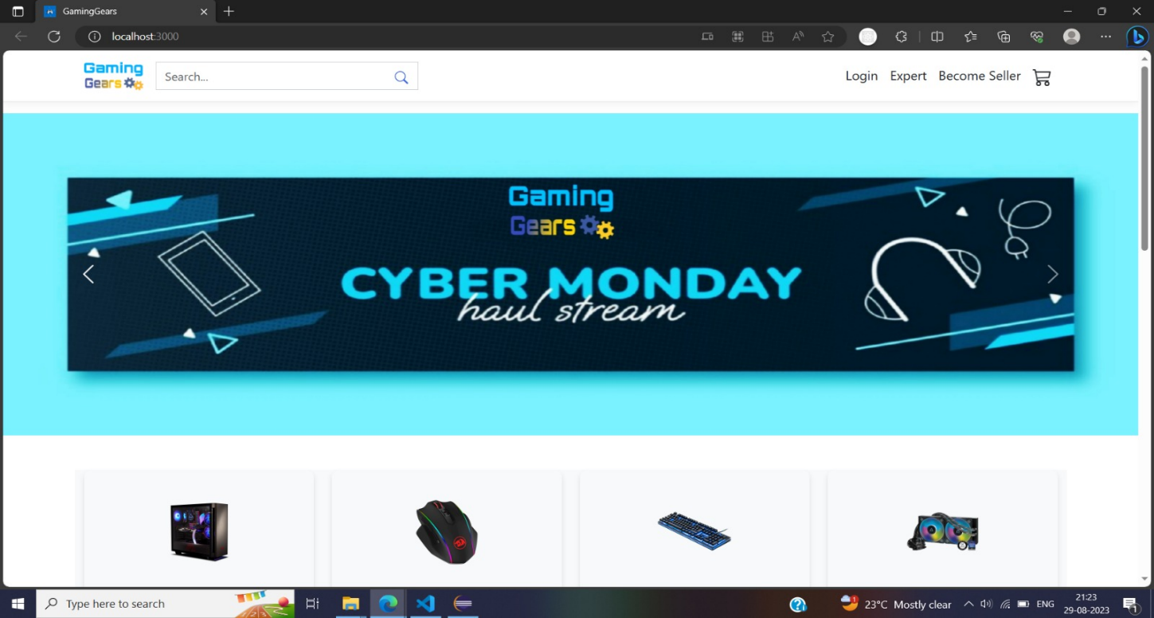

Home Page-1

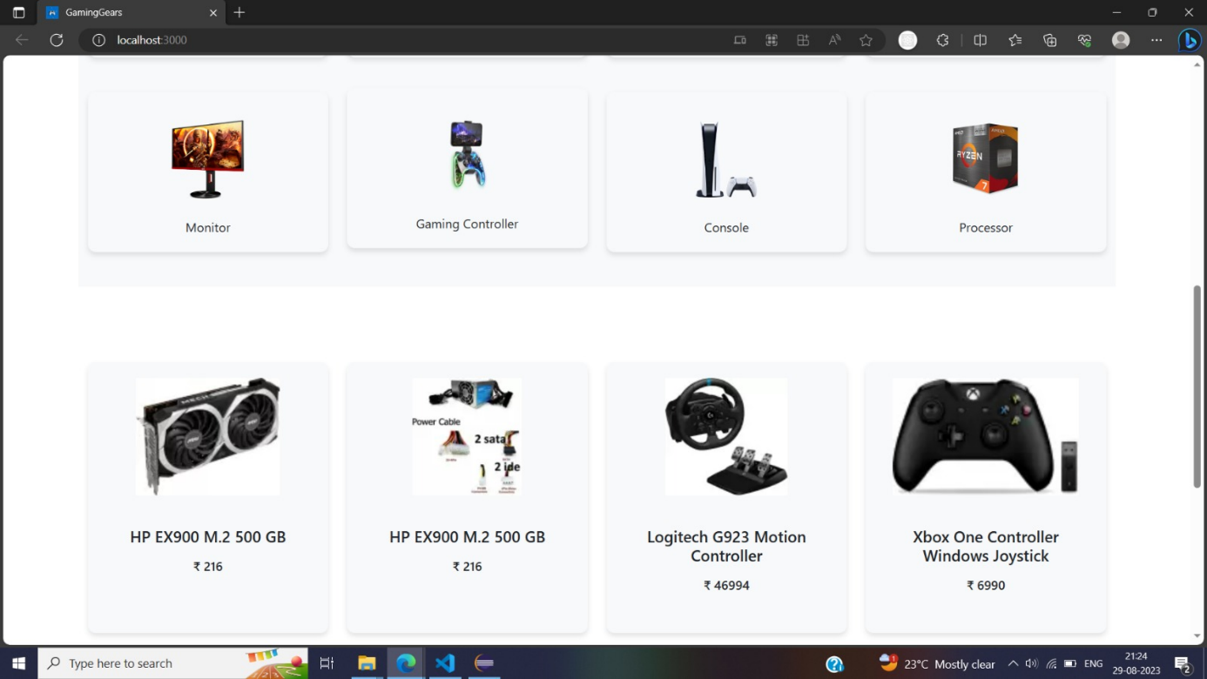

Home Page-2

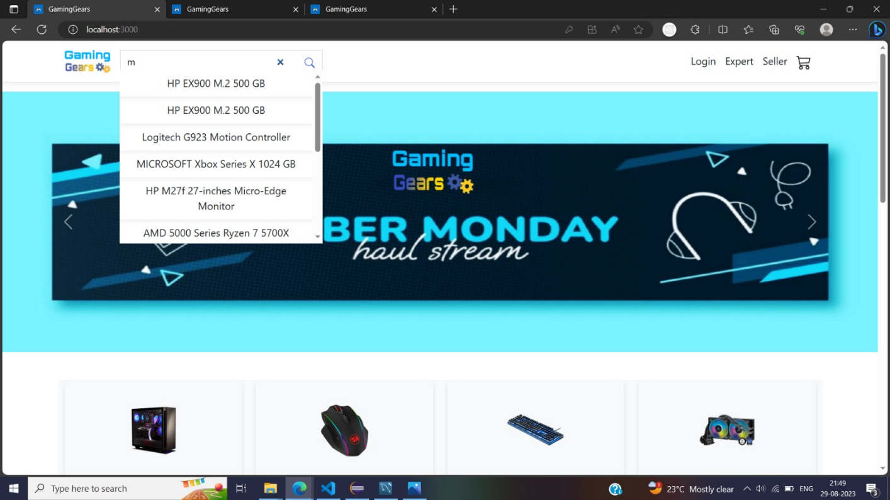

Search Product by Name

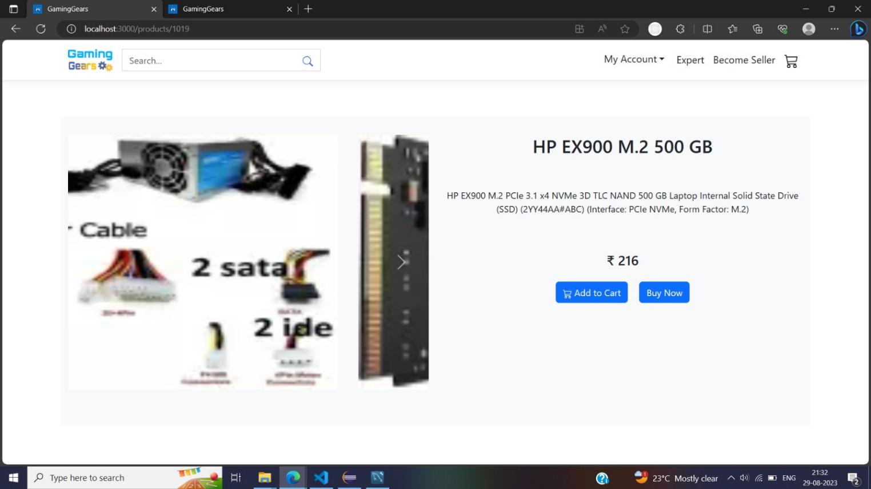

Product Detail

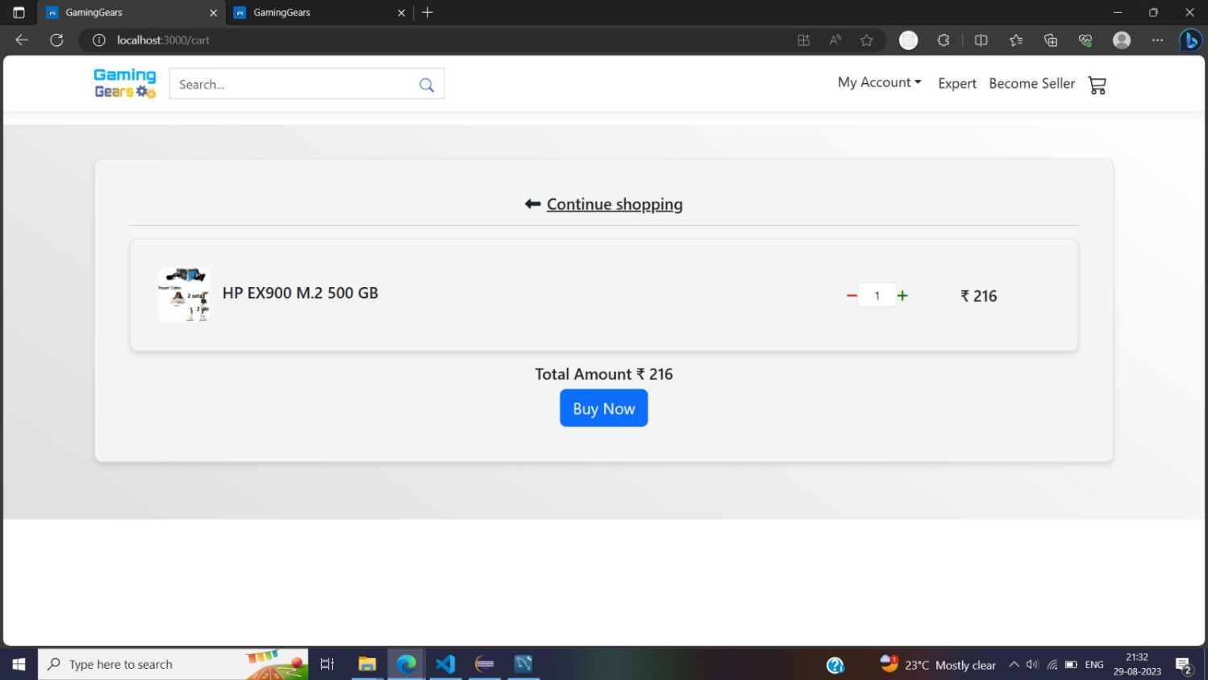

Cart

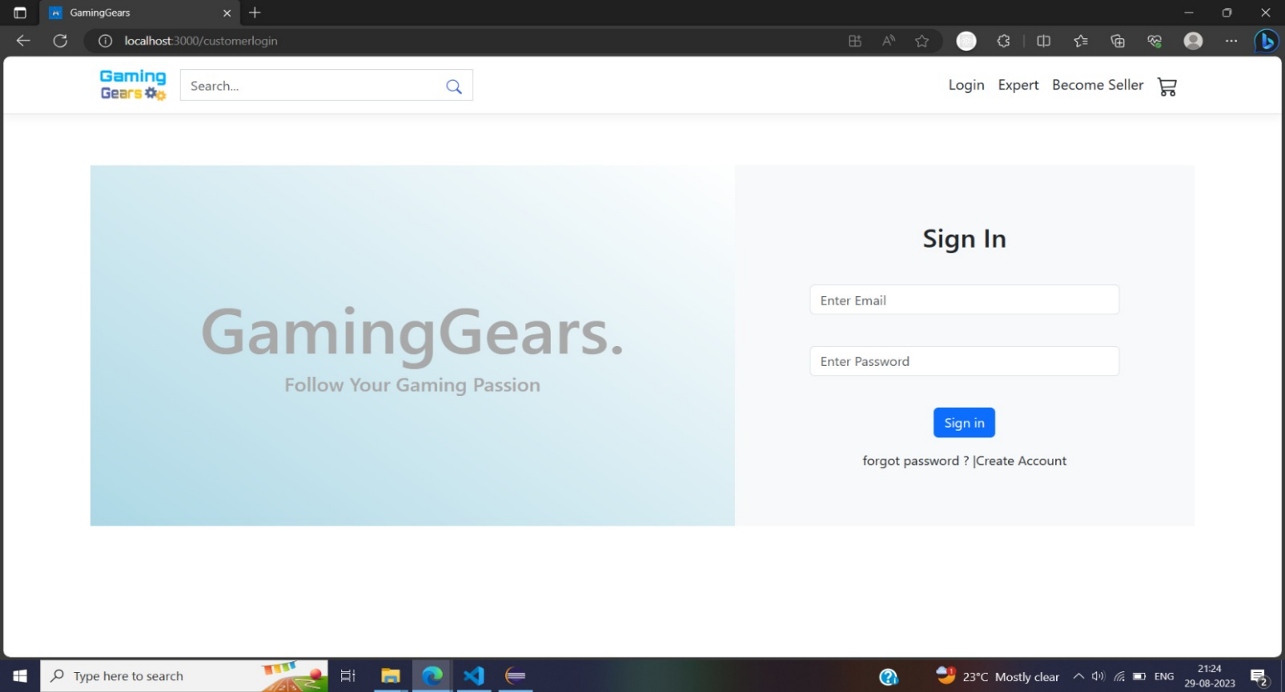

Customer Sign-In page

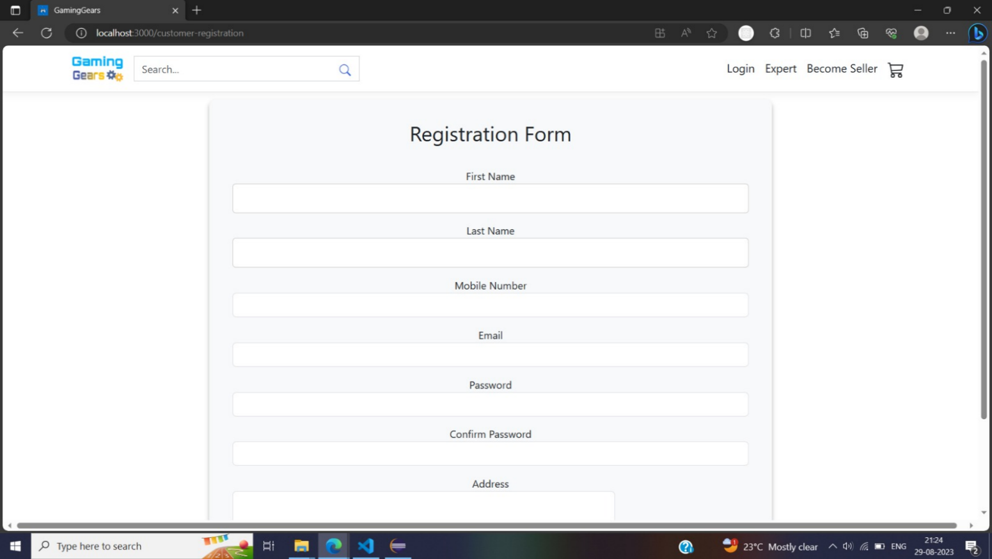

Customer Sign-Up page

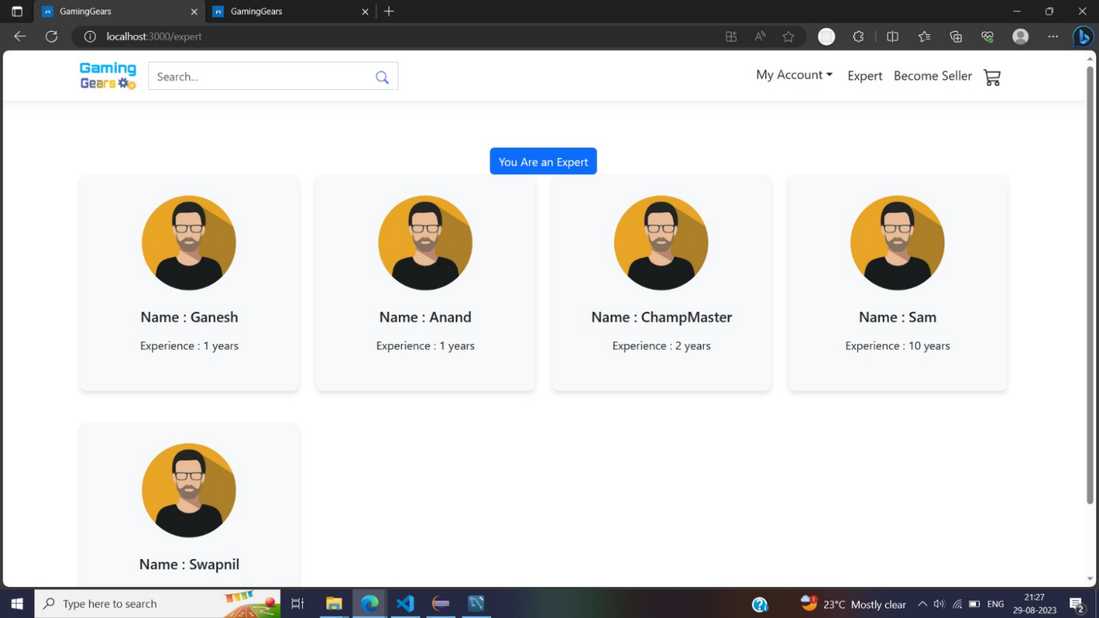

Expert Gallery Page

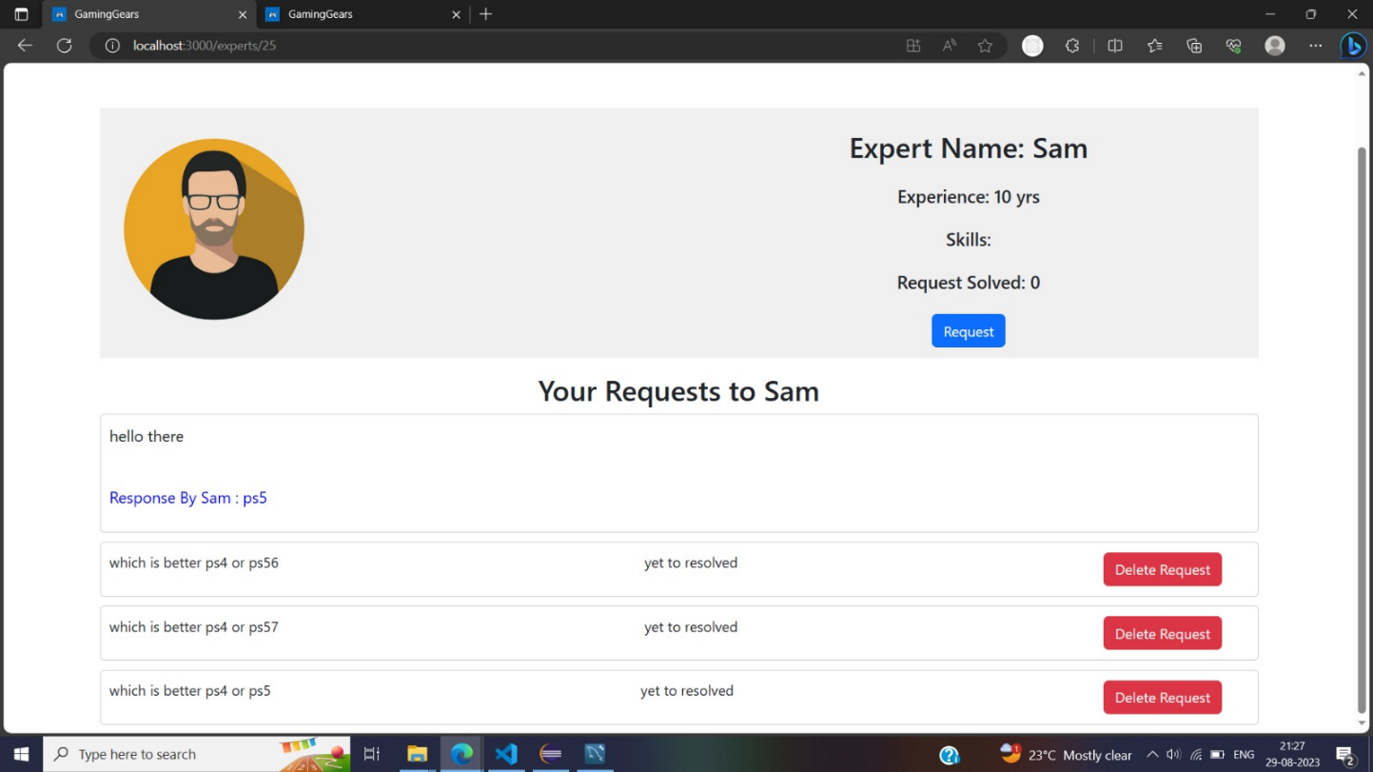

Expert Details

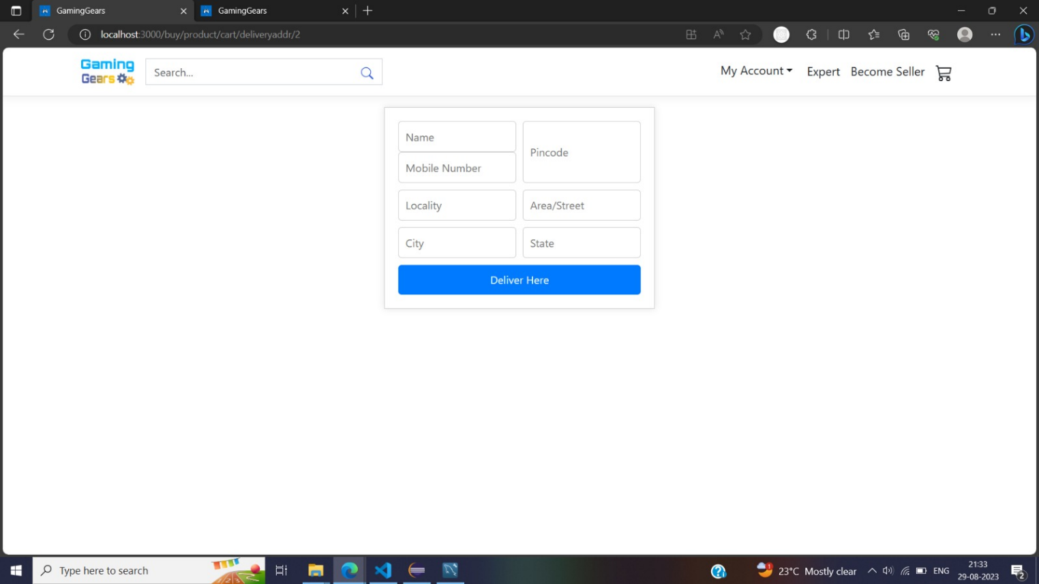

Delivery

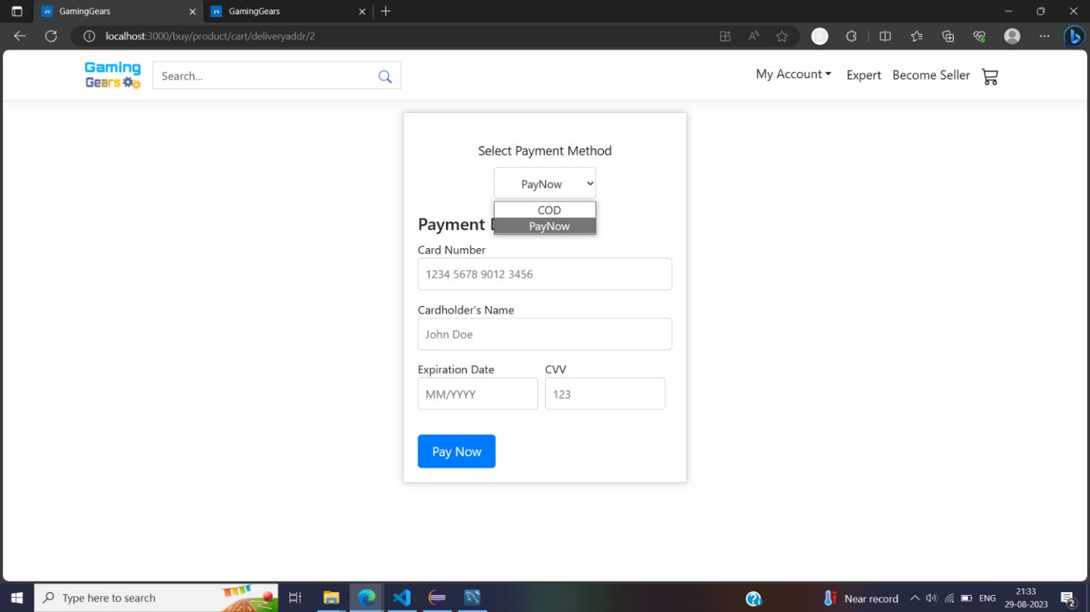

Payment

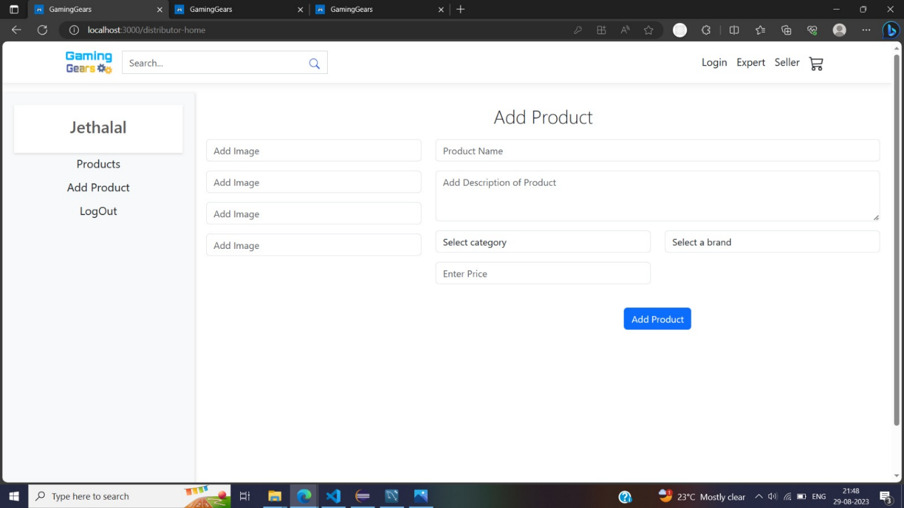

Add Product

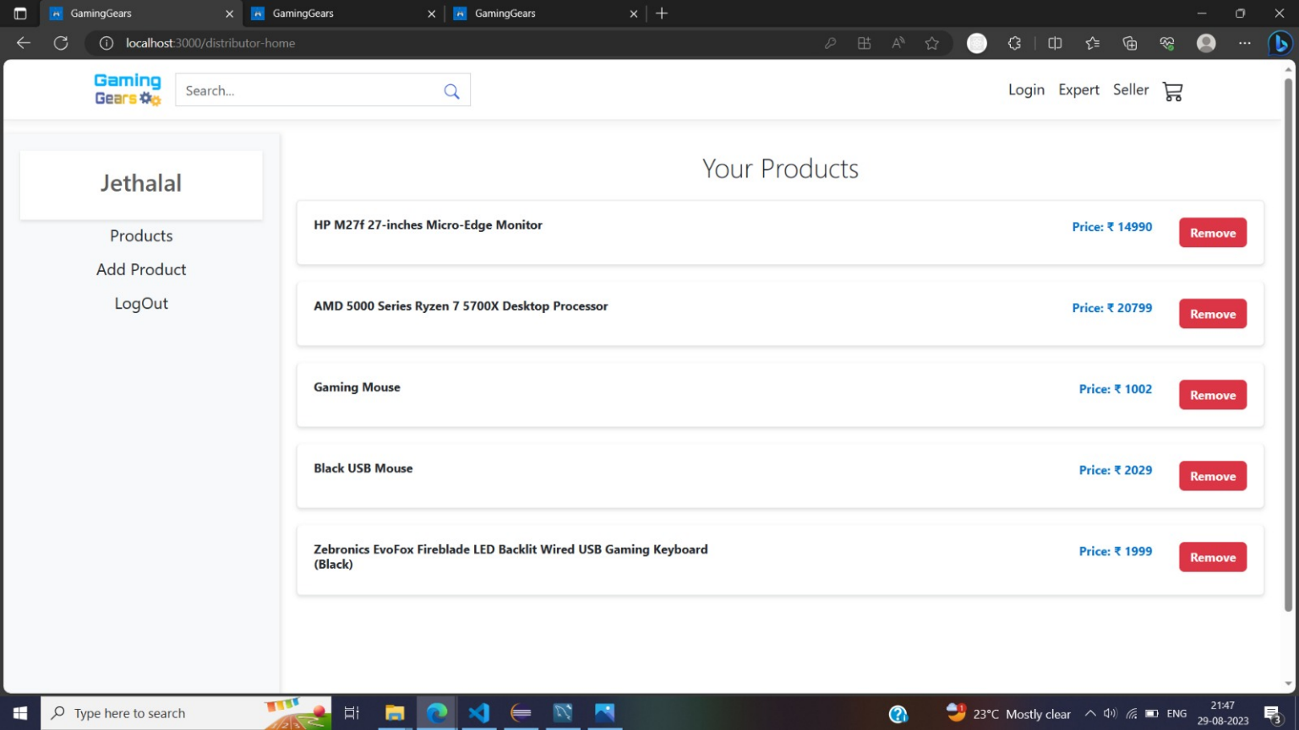

Display Product of Distributor

Admin Dashboard

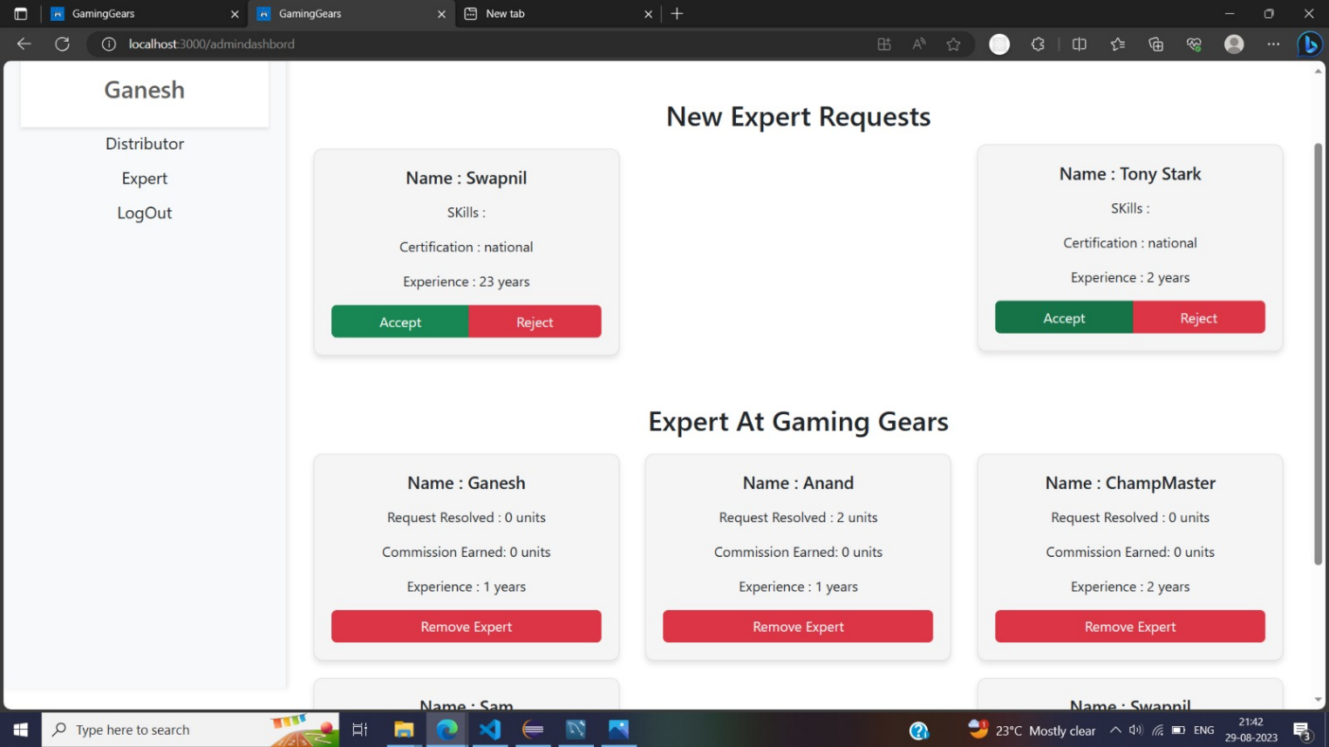

# References

1. YouTuberef:https://www.youtube.com/watch?v=9VsQ3mQcBnE&list=PL3JNi8Wv8Y4KJGQ0TgIno7sRHa1MtTn0e
2. React ref - https://reactjs.org/docs/getting-started.html
3. ER Diagram Tutorial: <https://www.lucidchart.com/pages/examples/er-diagram-tool>
4. Advance java Documentation ref - https://docs.oracle.com/en/java
5. Bootstrap ref: https://getbootstrap.com/docs/4.1